**Fanka Shundovska**

**JSON Extra Homework (Extra Assignements/Tests)**

**Write JSON path for:**

1. Retrieve category name JSON Path $.category.name

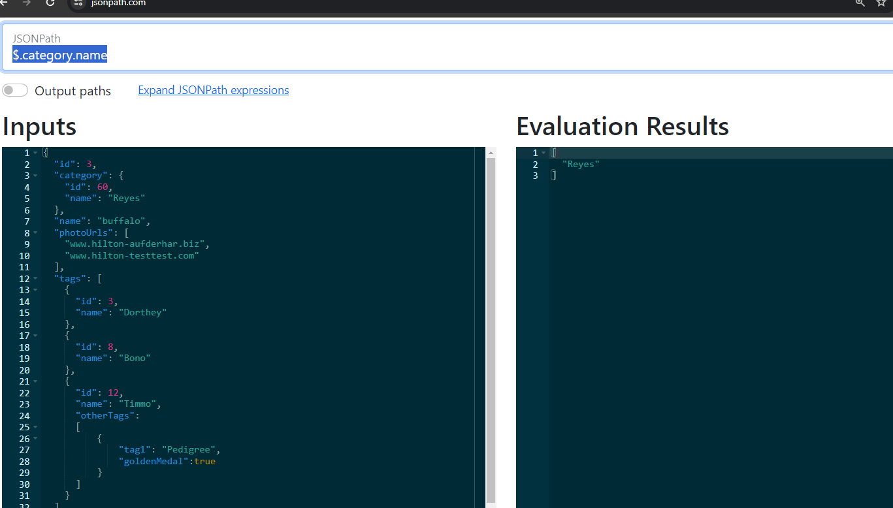

1. Find first PhotoUrl JSON Path $.photoUrls[0]

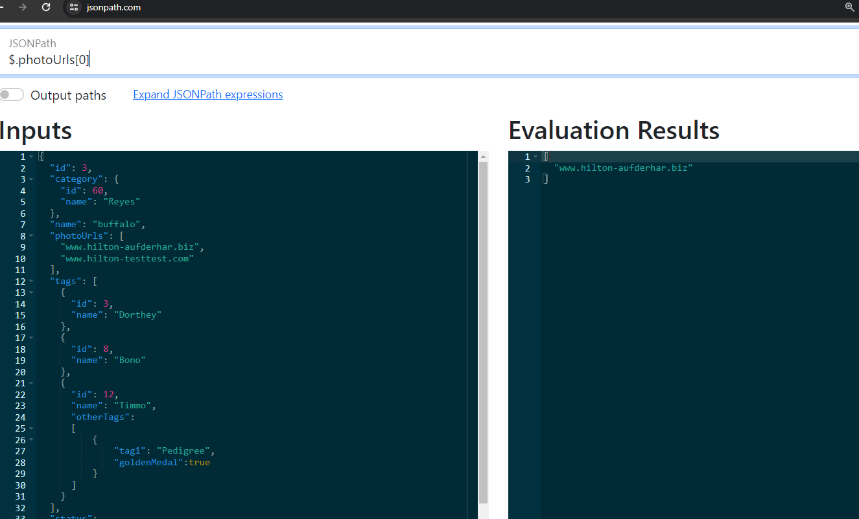

1. Find the first id JSON Path $.id

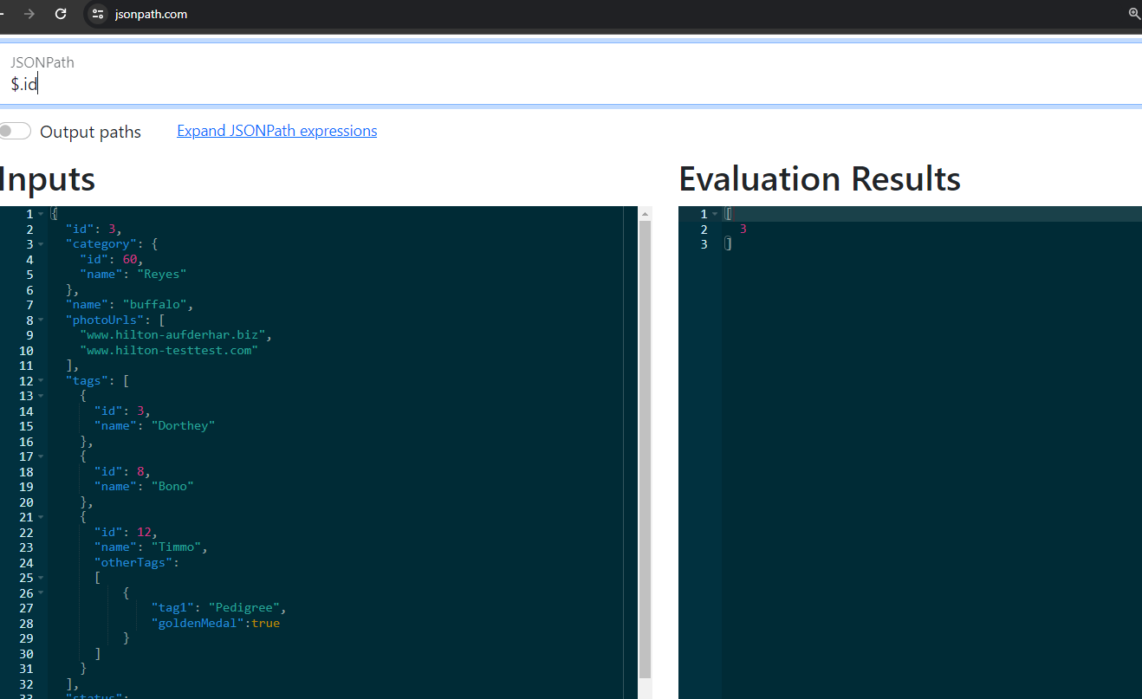

1stJSON Path from tags $.tags.[0].id

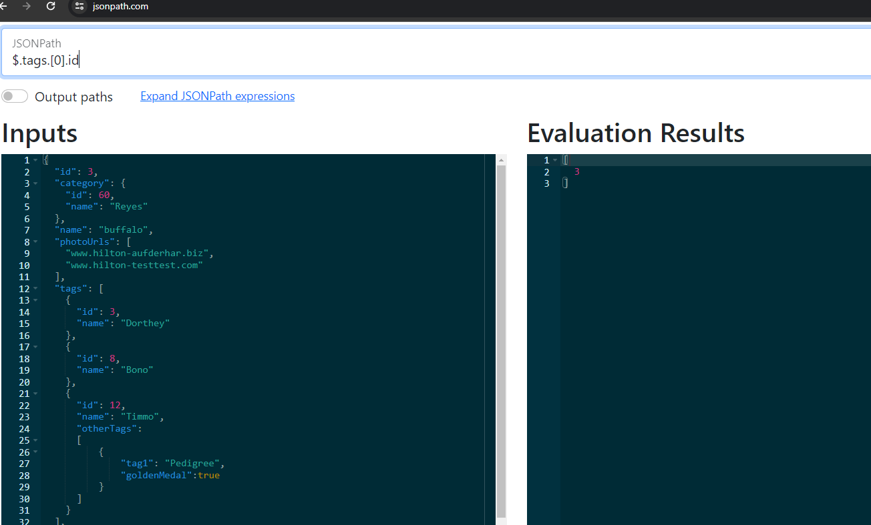

1. Find name Bono JSON Path $.tags.[1].name

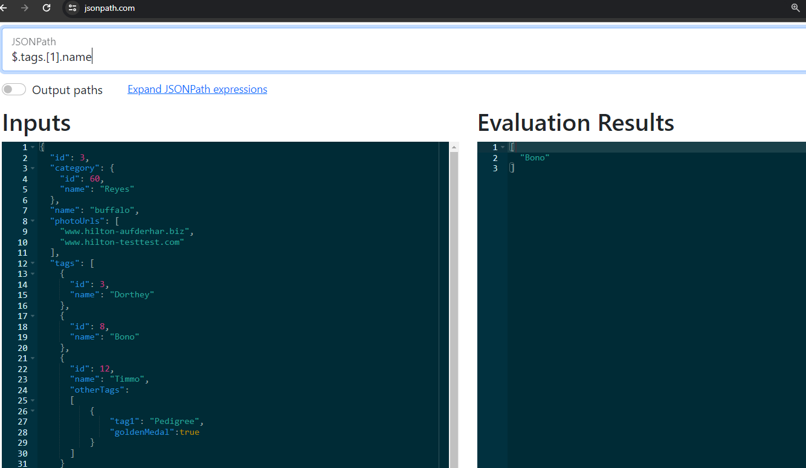

1. Retrieve all statuses JSON Path $.status

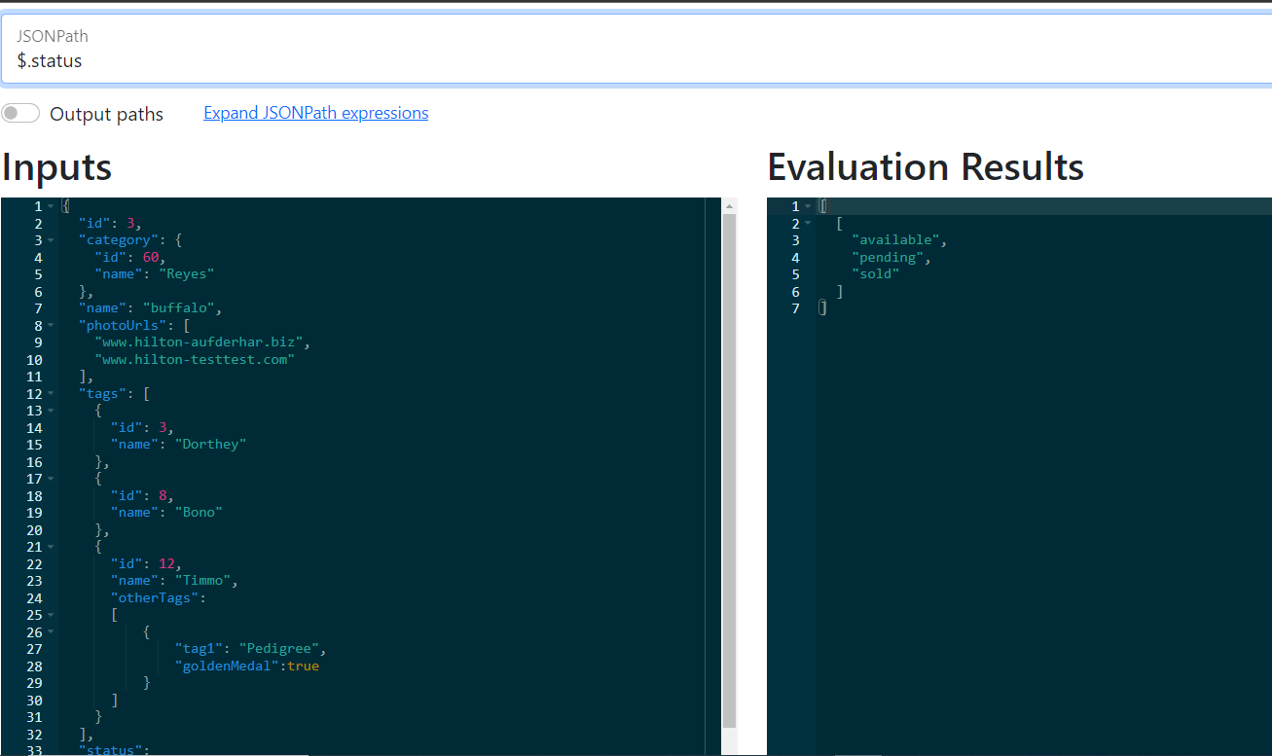

1. Find pending from statuses JSON Path $.status[1]

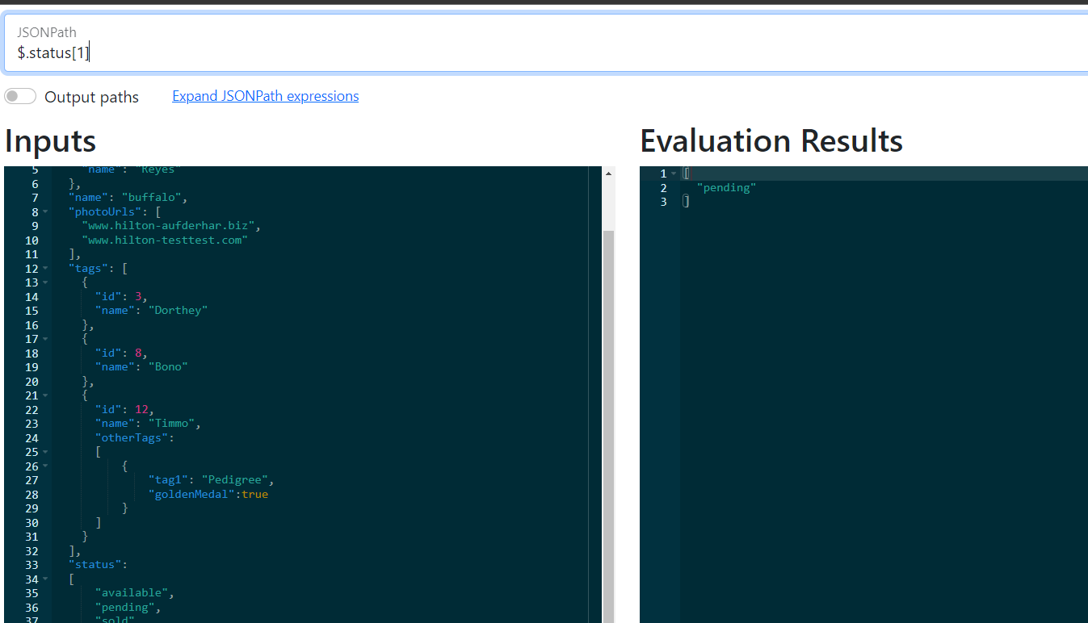

1. Find value of goldenMedal(true)

JSON Path $.tags[2].otherTags[0].goldenMedal

